Mineshield Edge Node

Overview:
Edge node is a raspberry pi that is installed at every checkpoint at the mining site.
It will have various devices connected to it like RFID reader, a thermal printer and camera(in future) and weighing scale(in future), the edge node will act as mediator between the platform and the devices. It will transform the data from the devices and send it to the platform via websocket and vice versa.
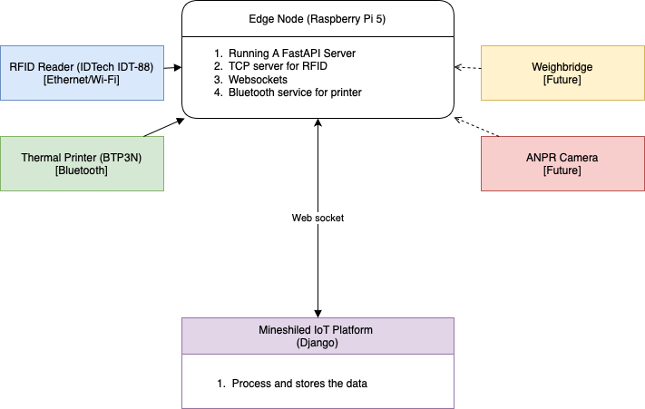

Hardware
RPI 5 4GB(RAM)
Case Argon Neo 5
SD Card(Samsung 128GB)
Power Adapter (Xiomi 33 W)

Building the Edge Node

- Hardware and OS Setup
- Assemble the case as per the instructions in the booklet provided inside the case packaging.
- Do not forget to apply the thermal pads.
- Burning the OS onto the SD card
  - Put the card in a reader and connect to the computer
  - Download the Raspberry pi Imager and install it in the system.
  - Click the choose device button and select Raspberry Pi 5
  - Click the choose OS button and select Raspberry Pi OS(other) and then select Raspberry Pi OS Lite (64 bit)
  - Click on the select storage button and select the SD card.
  - Once you click on the next it will as would you like to apply the OS customization settings
In the dialogue select the Edit Settings button
    - In the general tab
      - Give the hostname
      - Give the username and password (note it down somewhere)
      - Give ssid and password for the wifi
      - Set the locale for the timezone.
    - In the Services tab
      - Enable SSH
      - Check the radio button for use password authentication
Save and click Yes
  - Wait until the os is burned on the card.
- Now insert the SD card in raspberry pi and turn it on , It will be connected to the network using wifi, It can be also connected using the LAN.
- Login into the router and find the IP for the raspberry pi
- Map the MAC and IP so that each time the raspberry pi will have the same ip
- Now you can SSH into the pi using the username and password provided at the time for burning the OS.

B. Software Installation
First ssh into the raspberry pi
- Bluetooth Stack Setup
- Checking and installing the bluetooth stack:
Check the bluetooth stack with
which rfcomm
It should return a path like /usr/bin/rfcomm
If not install it manually by typing
sudo apt update
sudo apt install bluez
- Allowing the rfcomm to run without sudo
sudo setcap 'cap_net_admin=+ep' /usr/bin/rfcomm
- Connect the printer
  - Scan for nearby devices using
hcitool scan

  - Turn on the printer and connect to the raspberry pi using
sudo rfcomm bind /dev/rfcomm1 00:11:22:33:44:55 <mac address of the printer)
Improvement : please refine the shell script created for connecting the printer which will automatically take the mac from the env file from the project.

B. Memcached installation
- Install the memcached by
sudo apt update
sudo apt install memcached libmemcached-tools -y
- Run the memcached service by
sudo service start memcached

C. Hardware Configuration of the RFID Reader (IDT-88)
- Flashing the firmware
When the id tech delivers the readers they do not contain any firmware and that why we have flash the firmware before using the reader
Connect the reader to the computer using serial port and find the COM port of the connection using device manager in windows
Utility folder name is IDT-88-Flashing
Then open the flashing utility and flash using below steps:
1. Power off the reader .
2. Connect the COM port.
3. Open the flash.exe
4. Browse the .bin file.
5. Open the COM port
6. Click on the download button.
7. Power on the reader and wait to complete.
8. Once completed close the utility
9. Powerofff the reader
10. Disconnect the serial cable.
- Configuration Settings
- Configuration can be done using the IDT-88 windows app
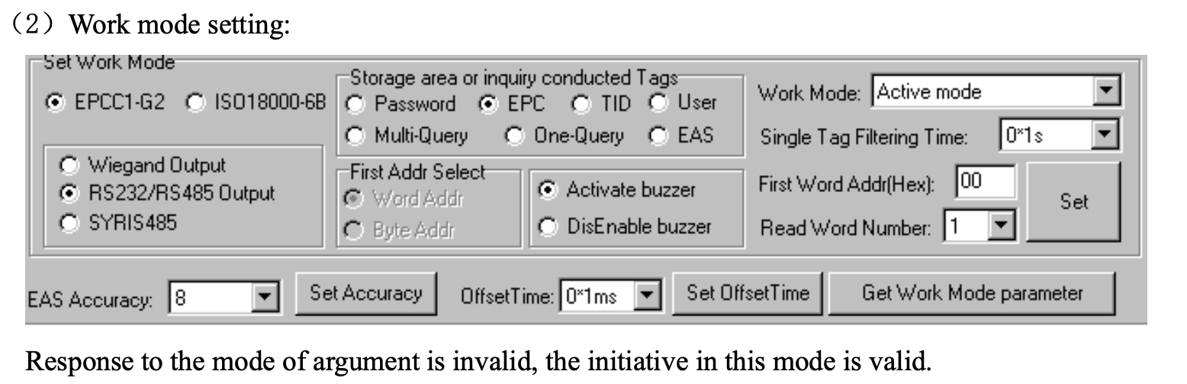
Once the firmware is flashed the reader should ideally start reading the tags but we need to do the additional configuration.
  - Connect the reader using the serial and configure using utility by opening the com port and open the IDT-88 App in windows.
  - configure parameters as per point 1.3 in the IDT user manual .
  - configure the work mode parameters as per the point 1.4 in IDT user manual
  - Keep the work mode as active
  - Now the serial can be disconnected.

3. Network configuration
- Connect the reader to the network (in the same subnet)
- The default ip of the reader will 192.168.1.190
- Go to the TCP/IP config tab if the utility and select the search
- If not found, restart the utility and try pinging the reader.
- Once found click on the ip and then click on the configuration button

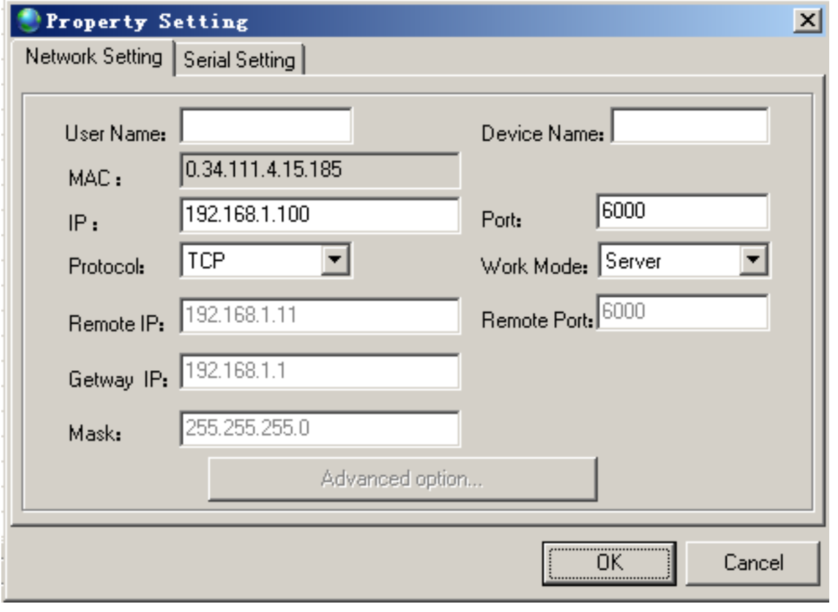

In the window
- Set the IP field as the desired ip for the reader.
- In the router map the ip and mac so that the reader will also have a static ip.
- Set the work mode as client
- In the Remote IP put the IP of the raspberry pi
- In the Gateway IP put the IP of the router (usually 192.168.1.1)
- In the Mask put the Subnet Mask (usually 255.255.255.0)
- In the Remote port put 5001 as It will be the port where the TCP server will listen for the requests.

D. Running the Server
- Edit the local ENV file of the project
- Make a config file for supervisord to run the server using uvicorn
- Also make a similar service to connect the printer and keep it connected.

Project Structure
app/
__init__.py
config.py
dependencies.py
main.py
external_services/
rfid.py
printer.py
dynamic_config.py
clients/
platform_websocket.py
client_protocol.py
handlers/
chekpoint.py
models/
routers/
checkpoint.py
schemas/
messages.py
utils/
receipt_templates.py
common.py
requirements.txt

Key Components

1. Configuration
- config.py
Uses Pydantic for environment-based configuration.
Example settings: platform_url, node_id, printer_device_path, etc.

2. RFID Reader
- rfid.py
Implements RFIDReader to listen for RFID tag data over TCP, deduplicate tags using memcache, and forward valid tags to the platform via WebSocket.

3. WebSocket Client
- platform_websocket.py
WebSocketClient manages the connection to the platform, listens for commands, and dispatches them to handlers.

4. Message Schemas
- messages.py
Defines all message payloads and types exchanged between the node and the platform, using Pydantic models.

5. Handlers
- chekpoint.py
Contains async handlers for platform messages, including updating config, handling vehicle identification, and printing receipts.

6. Printer Integration
- printer.py
Printer wraps the ESC/POS printer interface for receipt printing.
- Receipt_templates.py
ReceiptTemplate provides templates for different receipt types.(not used)

7. Dynamic Configuration
- dynamic_config.py
ConfigManager manages runtime configuration, persisted in JSON.

